**General Lab Safety Workshop** (Speaker: Ms. Ellen Elsbernd, Chief Occupational Safety and Health Administration (OSHA) Compliance Officer, Office of Environmental Health and Safety, UC; June 17, 2015, 2:45 pm–4:45 pm)

Ms. Elsbernd is the Chief OSHA (Occupational Safety and Health Administration) Compliance Officer for the Office of Environmental Health and Safety at UC, and has been addressing various safety and health concerns at the UC for the past 21 years. She is currently working on a special emphasis shop safety and machine safeguarding program. Ms. Elsbernd has two undergraduate degrees in Science Education and Forensic Chemistry, and an MBA in Operations Management. Prior to working with numerous health and safety concerns, Ms. Elsbernd taught high school chemistry.

Ms. Elsbernd began by introducing herself and getting an overview of the participants. Each participant stated their grade level and subject. Ms. Elsbernd then reviewed why the session was

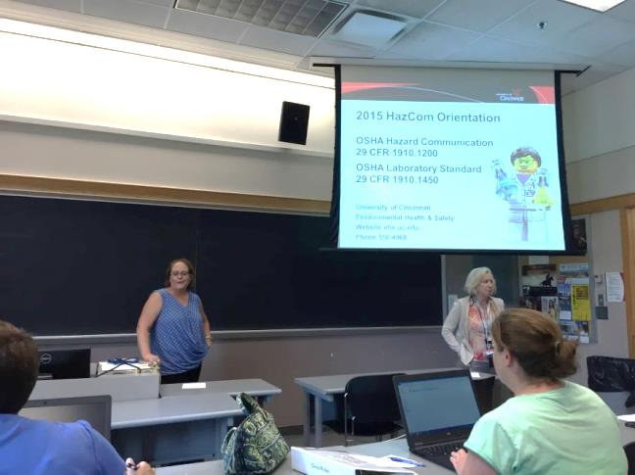

**Figure 1: Ellen Elsbernd Presenting Lab Safety Workshop**

important, to help meet OSHA standards for safety in labs and handed out a PowerPoint to all participants. An explanation on how OSHA standards meet United Nations global standards for uniform hazard protocols was explained for uniform handling of material. Revisions of SDS forms will be implemented by 2016 to meet global uniform standards. Anyone handling hazardous materials has a right to know the dangers involved and how to protect themselves.

Hazardous chemicals can pose a health hazard or a physical hazard. Data sheets state the type of hazard and an explanation of the hazard. Health hazards can be acute or chronic.

Health hazards can be sensitizers, carcinogens, toxic and highly toxic, irritants, corrosives, teratogens and organ specific. Physical hazards can be fire, reactive or explosive. Physical hazards can be inhalation, skin absorption, ingestion or injection. Guidelines have been set for the maximum limit of chemicals a person can be exposed to in parts per million. Exposure limits can be individually monitored and should not exceed recommended limit.

Safety Data Sheets are the tool used to communicate information on physical and chemical hazards. The sheets include identification, hazards, composition, first aid, firefighting measures, accidental release measures, handling and storage, exposure controls, physical and chemical properties, stability and reactivity, toxicological information, ecological information, disposal considerations, transport information and regulatory information. Each container should also contain a label (see **Figure 2** below), HCS pictograms and Hazards and all labs should display a Hazard Warning Diagram (see **Figure 3** below).

|  |  |
| --- | --- |
| **Figure 2: HCS Pictograms and Hazards Symbols** | **Figure 3: More Safety Hazards Symbols** |

The session ended with an explanation on controlling exposures. Exposure can be controlled by eliminating hazardous material by substituting less hazardous material, using less and/or purchasing only what is needed. An explanation on the proper use of a fume hood to prevent inhalation was explained. Good hygiene and workplace practices was explained, such as washing hands and how to store chemicals and use shield equipment. Wear personal protective equipment that is appropriate to chemicals such as coat, gloves, and location of eye washes was reviewed. Emergency preparedness such as exits, showers, fire extinguishers, electrical panels should be known before working in a lab. Principal investigators should be notified of all spills and assist in the cleanup. Clean up kits should be readily available. Pictures to identify improper practices were then reviewed.



**Figure 4: RET Teachers Participating in Safety Workshop**